**T. Y. B. Tech (Electrical and Computer Engineering)**

**Trimester: V Subject: Electric vehicle technology**

**Name: Shreerang Mhatre Class: TY BTECH EL&CE**

**Roll No: 52 Batch: A2**

**Experiment No: 01**

**Name of the Experiment:** Introduction to Simscape and Powertrain block set for EV simulation

**Marks**

**Teacher’s Signature with date**

**Performed on Submitted on**

**Aim:** To understand the building blocks of Simscape and Powertrain block set

**Resources:** Matlab 2022, Simscape toolbox, powertrain toolbox

# Theory:

Simscape is a tool in MATLAB/Simulink for modelling and simulating complex physical systems across multiple domains like electrical, mechanical, and hydraulic. It oﬀers pre-built component libraries, custom component creation, seamless integration with Simulink, parameterization, model reusability, and real-time simulation capabilities. It's widely used in industries such as automotive, aerospace, and robotics for system-level simulation and analysis.

1. What are the various building blocks that are present in Simscape for the EV simulation?
   * Current Sensor

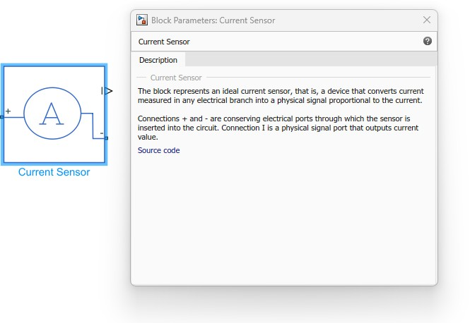

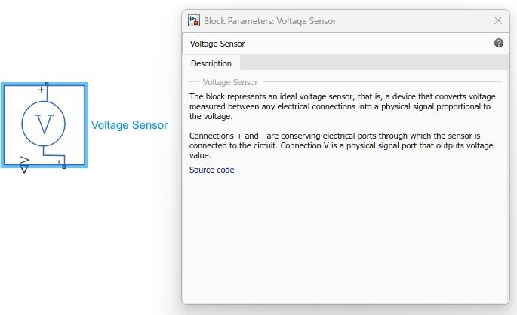

* IGBT

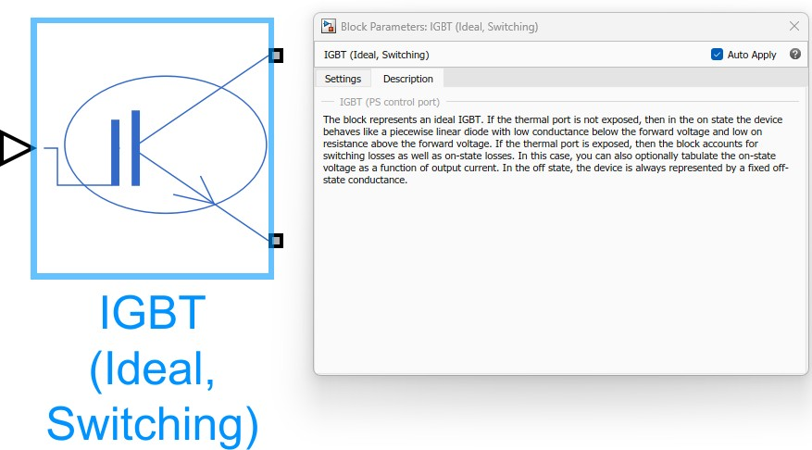

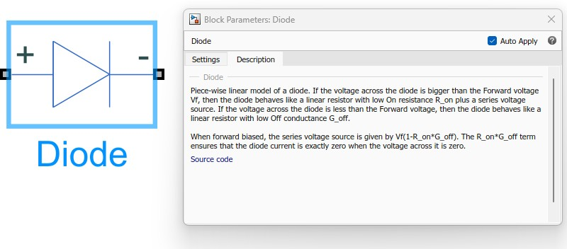

* Switch

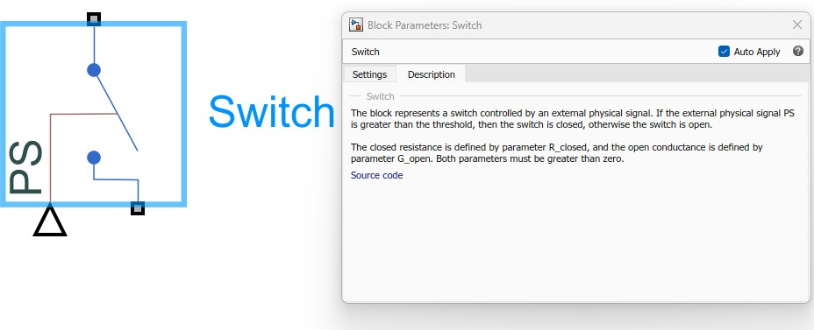

* Battery

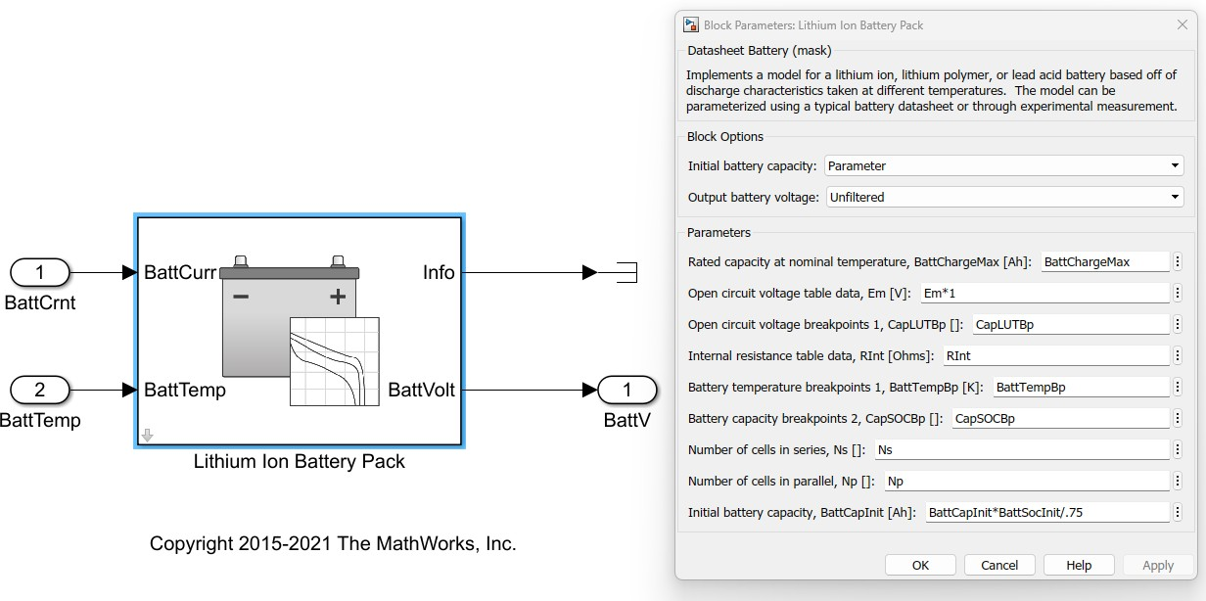

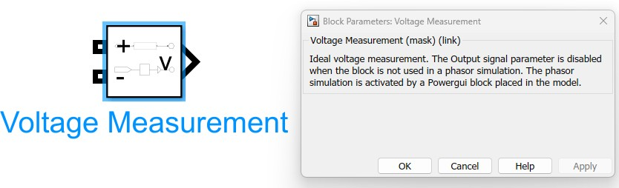

1. What are the various building blocks present in the power train block set for the EV simulation?

* Open diﬀerential

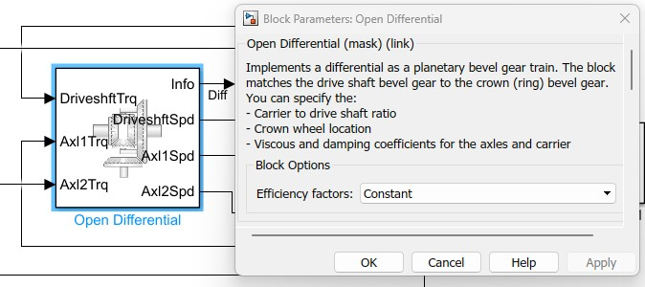

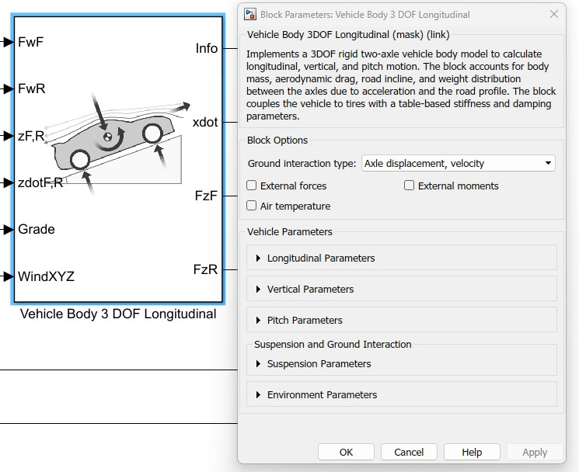

* Rotational Inertia

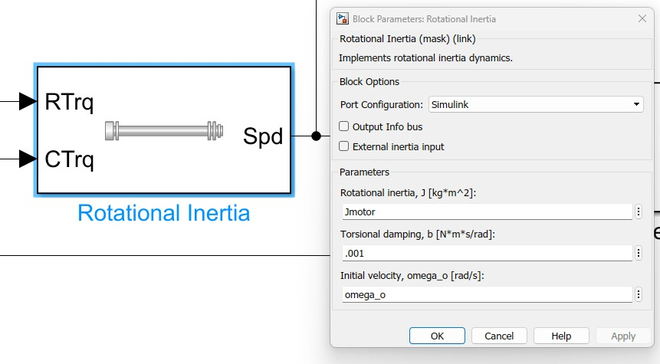

* Longitudinal wheel – front

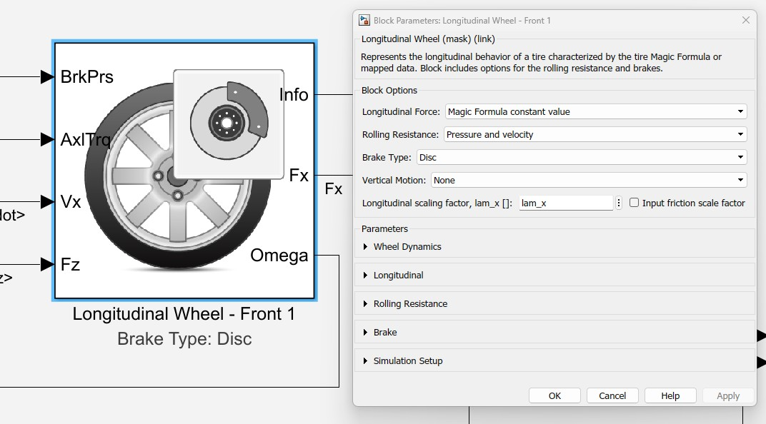

* Longitudinal wheel – Rear

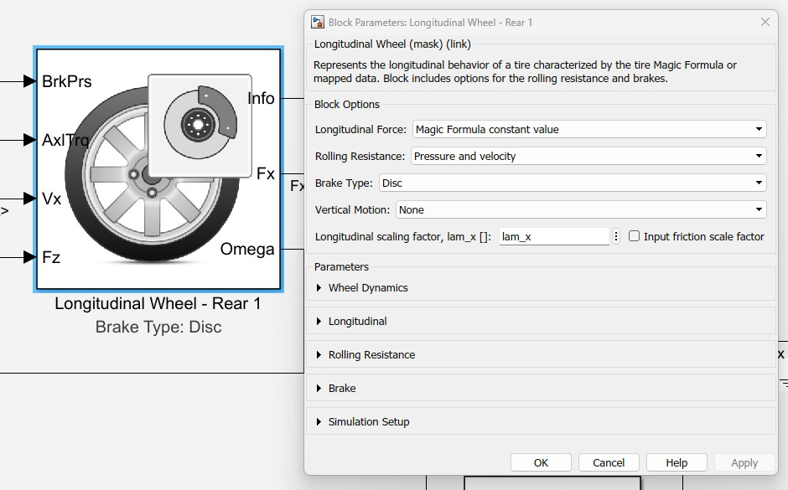

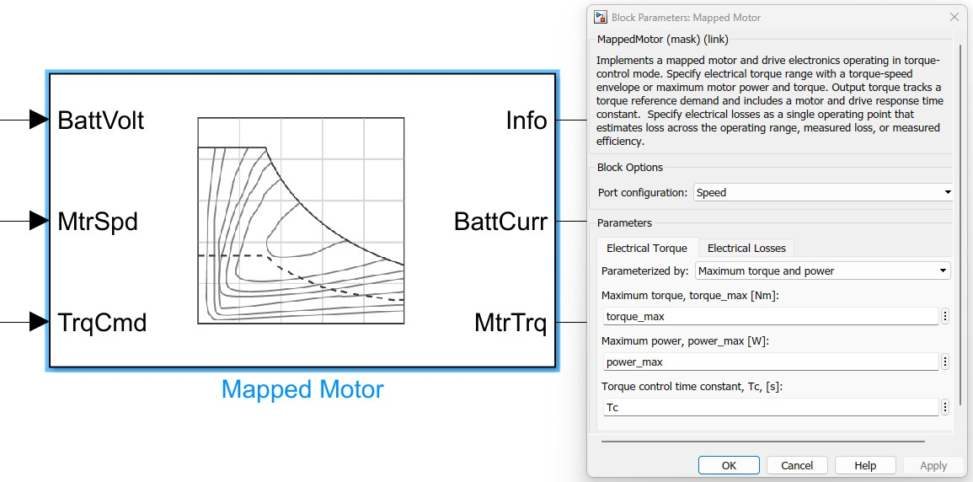

* Mapped SI Engine

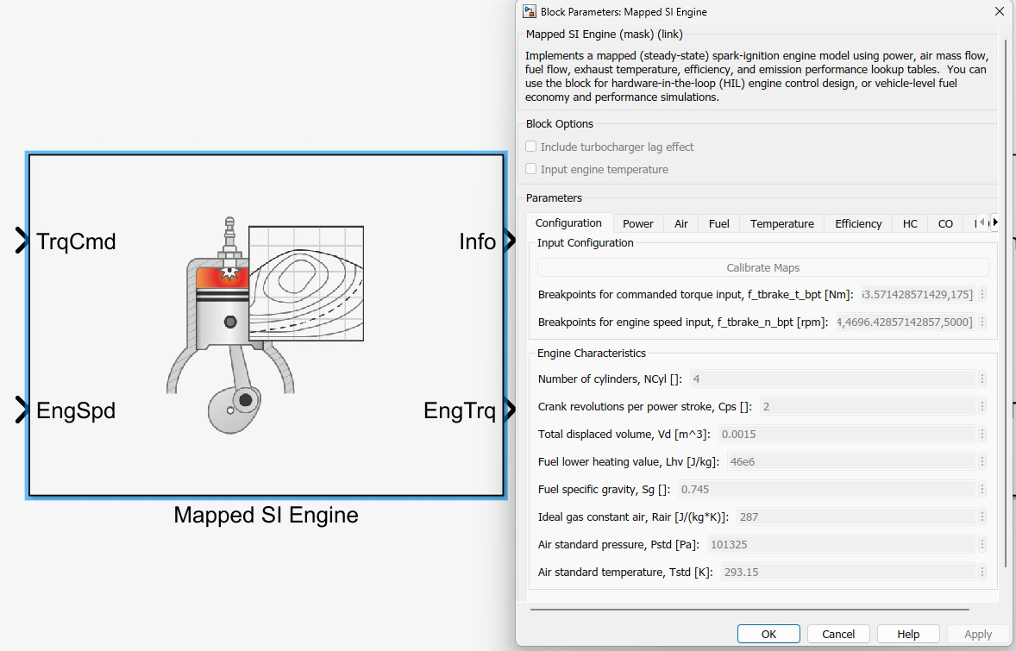

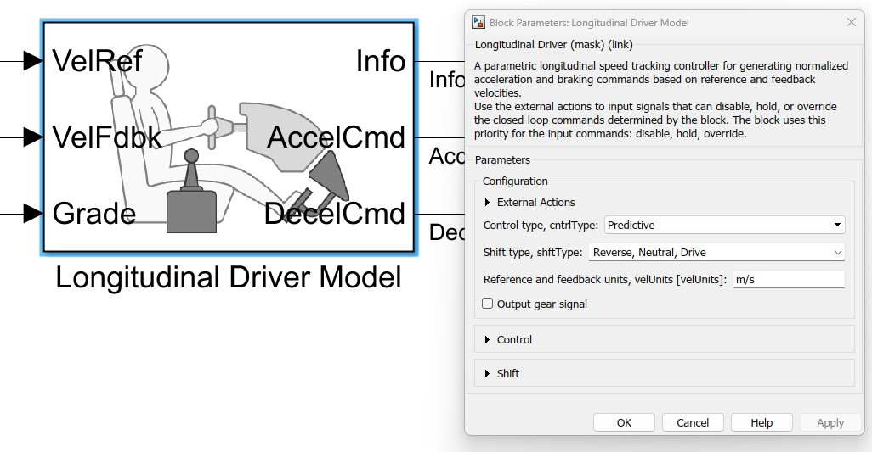

1. What are the various block sets that are present in Simscape or power train for battery modelling, electric drive building and simulation of power converters?

* Battery pack
* DC-DC converters

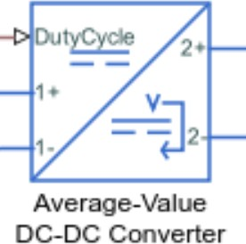The DC-DC Converter block represents a behavioural model of a power converter. This power converter regulates voltage on the load side. To balance input power, output power, and losses, the required amount of power is drawn from the supply side. Alternatively, the converter can support regenerative power ﬂow from load to supply.

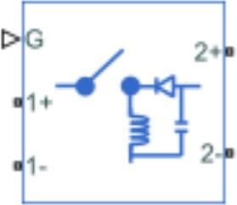

* MOSFET

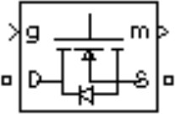

* 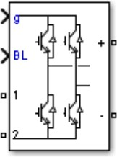Full Bridge power converter

The Buck-Boost Converter block represents a DC- DC converter that can either step up or step down DC voltage from one side of the converter to the other as driven by an attached controller and gate- signal generator. Buck-boost converters are also known as step-up/step-down voltage regulators because they can increase or decrease voltage

magnitude.

The metal-oxide semiconductor field-eﬀect transistor (MOSFET) is a semiconductor device controllable by the gate signal (g > 0). The MOSFET device is connected in parallel with an internal diode that turns on when the MOSFET device is reverse biased (Vds < 0) and no gate signal is applied (g=0). The model is simulated by an ideal switch controlled by a logical signal (g > 0 or g =0), with a diode connected in parallel.

The metal-oxide semiconductor field-eﬀect transistor (MOSFET) is a semiconductor device controllable by the gate signal (g > 0). The MOSFET device is connected in parallel with an internal diode that turns on when the MOSFET device is reverse biased (Vds < 0) and no gate signal is applied (g=0). The model is simulated by an ideal switch controlled by a logical signal (g > 0 or g =0), with a diode connected in parallel.

# Procedure:

1. Open MATLAB
2. Design the electrical component of the EV using the simscape and the power train block set available in MATLAB
3. Double-click the block icon to add the block to the simulation
4. Double-click the block to see the description of the block and set the parameters
5. Set the parameters to the required values and apply
6. Start the simulation

# Conclusion:

Understood the reason for using various blocks in building an EV simulation. Learned which building blocks belong to simscape and power train block set.